作业02 实体层及视图设计

 | 学号 | 姓名 | 本次作业中的主要工作 | 得分
组长 | 241548153 | 谭卓谦 | 完成 12 表简化设计并维护设计基线；更新数据库脚本、E-R 图与作业 01（12 表版）；提供字段与状态口径，核对实体类、映射文件与表结构的一致性。
组员1 | 241616118 | 陈志鹏 | 搭建 Spring Boot + MyBatis 工程骨架；编写 12 个实体类、12 个映射器接口与 12 个映射文件；完成登录注册、用户管理及 4 个业务模块的页面与静态资源（B 布局）。
组员2 | 241541217 | 刘梓烨 | 确认工程依赖与目录约定；起草接口约定（地址、请求方式、参数、返回字段、允许角色）；评审实体字段与页面所需数据的衔接，为作业 03 业务层与控制层做准备。

实体层设计
（1）用户管理模块（10分）
用户管理模块对应 user_account、role、user_role、menu 四张表，共 4 个映射器。学员和教练共用 user_account，用 id_number 和 coach_license 区分身份；菜单表直接带 role_id，登录后按用户角色查询并按访问路径去重。
映射器接口代码  (5分) | package com.example.drivingschool.mapper;  import com.example.drivingschool.entity.UserAccount;  import org.apache.ibatis.annotations.Param;  import java.util.List;  // 用户管理模块：账号与个人资料映射器  public interface UserAccountMapper {  UserAccount selectById(@Param("userId") Long userId);  UserAccount selectByUsername(@Param("username") String username);  List<UserAccount> selectList(@Param("keyword") String keyword, @Param("enabled") Boolean enabled);  int countByUsername(@Param("username") String username);  int countByPhone(@Param("phone") String phone);  int countByIdNumber(@Param("idNumber") String idNumber);  int insert(UserAccount userAccount);  int updateById(UserAccount userAccount);  int updatePassword(@Param("userId") Long userId, @Param("passwordHash") String passwordHash);  int updateEnabled(@Param("userId") Long userId, @Param("enabled") Boolean enabled);  // 删除账号前检查业务引用：有报名、培训、答卷、退费记录就不允许删  int countBusinessReference(@Param("userId") Long userId);  int deleteById(@Param("userId") Long userId);  }  package com.example.drivingschool.mapper;  import com.example.drivingschool.entity.Role;  import org.apache.ibatis.annotations.Param;  import java.util.List;  // 用户管理模块：角色映射器  public interface RoleMapper {  Role selectById(@Param("roleId") Long roleId);  Role selectByCode(@Param("roleCode") String roleCode);  List<Role> selectList();  // 查某个用户拥有的全部角色，多角色用户会返回多行  List<Role> selectByUserId(@Param("userId") Long userId);  int countByCode(@Param("roleCode") String roleCode);  int insert(Role role);  int updateById(Role role);  int countUserReference(@Param("roleId") Long roleId);  int deleteById(@Param("roleId") Long roleId);  }  package com.example.drivingschool.mapper;  import com.example.drivingschool.entity.UserRole;  import org.apache.ibatis.annotations.Param;  import java.util.List;  // 用户管理模块：用户角色关系映射器，联合主键 (user_id, role_id)  public interface UserRoleMapper {  int insert(@Param("userId") Long userId, @Param("roleId") Long roleId);  int insertBatch(@Param("userId") Long userId, @Param("roleIds") List<Long> roleIds);  List<UserRole> selectByUserId(@Param("userId") Long userId);  int countByUserIdAndRoleId(@Param("userId") Long userId, @Param("roleId") Long roleId);  int delete(@Param("userId") Long userId, @Param("roleId") Long roleId);  // 重新分配角色前先清空  int deleteByUserId(@Param("userId") Long userId);  }  package com.example.drivingschool.mapper;  import com.example.drivingschool.entity.Menu;  import org.apache.ibatis.annotations.Param;  import java.util.List;  // 用户管理模块：菜单映射器  public interface MenuMapper {  Menu selectById(@Param("menuId") Long menuId);  List<Menu> selectList(@Param("roleId") Long roleId, @Param("enabled") Boolean enabled);  // 查某个用户能看到的菜单，按 route_path 去重，多角色共用同一路径时只留一条  List<Menu> selectByUserId(@Param("userId") Long userId);  int countByRoleIdAndCode(@Param("roleId") Long roleId, @Param("menuCode") String menuCode);  int insert(Menu menu);  int updateById(Menu menu);  int updateEnabled(@Param("menuId") Long menuId, @Param("enabled") Boolean enabled);  int deleteById(@Param("menuId") Long menuId);  }
映射文件内容(5分) | <?xml version="1.0" encoding="UTF-8"?>  <!DOCTYPE mapper PUBLIC "-//mybatis.org//DTD Mapper 3.0//EN"  "http://mybatis.org/dtd/mybatis-3-mapper.dtd">  <mapper namespace="com.example.drivingschool.mapper.UserAccountMapper">  <resultMap id="BaseResultMap" type="UserAccount">  <id property="userId" column="user_id"/>  <result property="username" column="username"/>  <result property="passwordHash" column="password_hash"/>  <result property="realName" column="real_name"/>  <result property="phone" column="phone"/>  <result property="gender" column="gender"/>  <result property="idNumber" column="id_number"/>  <result property="coachLicense" column="coach_license"/>  <result property="enabled" column="enabled"/>  <result property="createdAt" column="created_at"/>  </resultMap>  <sql id="BaseColumns">  user_id, username, password_hash, real_name, phone, gender,  id_number, coach_license, enabled, created_at  </sql>  <select id="selectById" resultMap="BaseResultMap">  SELECT <include refid="BaseColumns"/> FROM user_account WHERE user_id = #{userId}  </select>  <select id="selectByUsername" resultMap="BaseResultMap">  SELECT <include refid="BaseColumns"/> FROM user_account WHERE username = #{username}  </select>  <select id="selectList" resultMap="BaseResultMap">  SELECT <include refid="BaseColumns"/>  FROM user_account  <where>  <if test="keyword != null and keyword != ''">  (username LIKE CONCAT('%', #{keyword}, '%')  OR real_name LIKE CONCAT('%', #{keyword}, '%')  OR phone LIKE CONCAT('%', #{keyword}, '%'))  </if>  <if test="enabled != null">AND enabled = #{enabled}</if>  </where>  ORDER BY user_id  </select>  <select id="countByUsername" resultType="int">  SELECT COUNT(*) FROM user_account WHERE username = #{username}  </select>  <select id="countByPhone" resultType="int">  SELECT COUNT(*) FROM user_account WHERE phone = #{phone}  </select>  <select id="countByIdNumber" resultType="int">  SELECT COUNT(*) FROM user_account WHERE id_number = #{idNumber}  </select>  <insert id="insert" parameterType="UserAccount" useGeneratedKeys="true" keyProperty="userId">  INSERT INTO user_account (username, password_hash, real_name, phone, gender,  id_number, coach_license, enabled)  VALUES (#{username}, #{passwordHash}, #{realName}, #{phone}, #{gender},  #{idNumber}, #{coachLicense}, COALESCE(#{enabled}, TRUE))  </insert>  <update id="updateById" parameterType="UserAccount">  UPDATE user_account  <set>  <if test="realName != null and realName != ''">real_name = #{realName},</if>  <if test="phone != null and phone != ''">phone = #{phone},</if>  <if test="gender != null and gender != ''">gender = #{gender},</if>  <if test="idNumber != null and idNumber != ''">id_number = #{idNumber},</if>  <if test="coachLicense != null and coachLicense != ''">coach_license = #{coachLicense},</if>  </set>  WHERE user_id = #{userId}  </update>  <update id="updatePassword">  UPDATE user_account SET password_hash = #{passwordHash} WHERE user_id = #{userId}  </update>  <update id="updateEnabled">  UPDATE user_account SET enabled = #{enabled} WHERE user_id = #{userId}  </update>  <!-- 账号被业务表引用的情况，有引用就只能停用不能删除 -->  <select id="countBusinessReference" resultType="int">  SELECT  (SELECT COUNT(*) FROM enrollment WHERE student_user_id = #{userId}  OR reviewed_by = #{userId} OR paid_by = #{userId})  + (SELECT COUNT(*) FROM training_booking WHERE student_user_id = #{userId}  OR coach_user_id = #{userId}  OR created_by = #{userId} OR assigned_by = #{userId})  + (SELECT COUNT(*) FROM mock_exam WHERE submitted_by = #{userId} OR reviewed_by = #{userId})  + (SELECT COUNT(*) FROM exam_attempt WHERE student_user_id = #{userId})  + (SELECT COUNT(*) FROM withdrawal_request WHERE reviewed_by = #{userId} OR refunded_by = #{userId})  </select>  <delete id="deleteById">  DELETE FROM user_account WHERE user_id = #{userId}  </delete>  </mapper>  <?xml version="1.0" encoding="UTF-8"?>  <!DOCTYPE mapper PUBLIC "-//mybatis.org//DTD Mapper 3.0//EN"  "http://mybatis.org/dtd/mybatis-3-mapper.dtd">  <mapper namespace="com.example.drivingschool.mapper.RoleMapper">  <resultMap id="BaseResultMap" type="Role">  <id property="roleId" column="role_id"/>  <result property="roleCode" column="role_code"/>  <result property="roleName" column="role_name"/>  </resultMap>  <sql id="BaseColumns">role_id, role_code, role_name</sql>  <select id="selectById" resultMap="BaseResultMap">  SELECT <include refid="BaseColumns"/> FROM role WHERE role_id = #{roleId}  </select>  <select id="selectByCode" resultMap="BaseResultMap">  SELECT <include refid="BaseColumns"/> FROM role WHERE role_code = #{roleCode}  </select>  <select id="selectList" resultMap="BaseResultMap">  SELECT <include refid="BaseColumns"/> FROM role ORDER BY role_id  </select>  <select id="selectByUserId" resultMap="BaseResultMap">  SELECT r.role_id, r.role_code, r.role_name  FROM user_role ur  JOIN role r ON r.role_id = ur.role_id  WHERE ur.user_id = #{userId}  ORDER BY r.role_id  </select>  <select id="countByCode" resultType="int">  SELECT COUNT(*) FROM role WHERE role_code = #{roleCode}  </select>  <insert id="insert" parameterType="Role" useGeneratedKeys="true" keyProperty="roleId">  INSERT INTO role (role_code, role_name) VALUES (#{roleCode}, #{roleName})  </insert>  <update id="updateById" parameterType="Role">  UPDATE role  <set>  <if test="roleCode != null and roleCode != ''">role_code = #{roleCode},</if>  <if test="roleName != null and roleName != ''">role_name = #{roleName},</if>  </set>  WHERE role_id = #{roleId}  </update>  <select id="countUserReference" resultType="int">  SELECT COUNT(*) FROM user_role WHERE role_id = #{roleId}  </select>  <delete id="deleteById">  DELETE FROM role WHERE role_id = #{roleId}  </delete>  </mapper>  <?xml version="1.0" encoding="UTF-8"?>  <!DOCTYPE mapper PUBLIC "-//mybatis.org//DTD Mapper 3.0//EN"  "http://mybatis.org/dtd/mybatis-3-mapper.dtd">  <mapper namespace="com.example.drivingschool.mapper.UserRoleMapper">  <resultMap id="BaseResultMap" type="UserRole">  <result property="userId" column="user_id"/>  <result property="roleId" column="role_id"/>  </resultMap>  <insert id="insert">  INSERT INTO user_role (user_id, role_id) VALUES (#{userId}, #{roleId})  </insert>  <insert id="insertBatch">  INSERT INTO user_role (user_id, role_id) VALUES  <foreach collection="roleIds" item="roleId" separator=",">  (#{userId}, #{roleId})  </foreach>  </insert>  <select id="selectByUserId" resultMap="BaseResultMap">  SELECT user_id, role_id FROM user_role WHERE user_id = #{userId} ORDER BY role_id  </select>  <select id="countByUserIdAndRoleId" resultType="int">  SELECT COUNT(*) FROM user_role WHERE user_id = #{userId} AND role_id = #{roleId}  </select>  <delete id="delete">  DELETE FROM user_role WHERE user_id = #{userId} AND role_id = #{roleId}  </delete>  <delete id="deleteByUserId">  DELETE FROM user_role WHERE user_id = #{userId}  </delete>  </mapper>  <?xml version="1.0" encoding="UTF-8"?>  <!DOCTYPE mapper PUBLIC "-//mybatis.org//DTD Mapper 3.0//EN"  "http://mybatis.org/dtd/mybatis-3-mapper.dtd">  <mapper namespace="com.example.drivingschool.mapper.MenuMapper">  <resultMap id="BaseResultMap" type="Menu">  <id property="menuId" column="menu_id"/>  <result property="roleId" column="role_id"/>  <result property="menuCode" column="menu_code"/>  <result property="menuName" column="menu_name"/>  <result property="routePath" column="route_path"/>  <result property="sortNo" column="sort_no"/>  <result property="enabled" column="enabled"/>  </resultMap>  <sql id="BaseColumns">menu_id, role_id, menu_code, menu_name, route_path, sort_no, enabled</sql>  <select id="selectById" resultMap="BaseResultMap">  SELECT <include refid="BaseColumns"/> FROM menu WHERE menu_id = #{menuId}  </select>  <select id="selectList" resultMap="BaseResultMap">  SELECT <include refid="BaseColumns"/>  FROM menu  <where>  <if test="roleId != null">role_id = #{roleId}</if>  <if test="enabled != null">AND enabled = #{enabled}</if>  </where>  ORDER BY role_id, sort_no, menu_id  </select>  <!-- 菜单按当前用户的角色查询，再按 route_path 去重： 多角色用户对同一路径只保留 menu_id 最小的那条，避免菜单重复。 这正是 academic（同时是教务和教练）既能看报名审核又不重复看培训的原因。 -->  <select id="selectByUserId" resultMap="BaseResultMap">  SELECT m.menu_id, m.role_id, m.menu_code, m.menu_name, m.route_path, m.sort_no, m.enabled  FROM menu m  JOIN user_role ur ON ur.role_id = m.role_id  WHERE ur.user_id = #{userId}  AND m.enabled = TRUE  AND m.menu_id = (  SELECT MIN(m2.menu_id)  FROM menu m2  JOIN user_role ur2 ON ur2.role_id = m2.role_id  WHERE ur2.user_id = #{userId}  AND m2.route_path = m.route_path  AND m2.enabled = TRUE  )  ORDER BY m.sort_no, m.menu_id  </select>  <select id="countByRoleIdAndCode" resultType="int">  SELECT COUNT(*) FROM menu WHERE role_id = #{roleId} AND menu_code = #{menuCode}  </select>  <insert id="insert" parameterType="Menu" useGeneratedKeys="true" keyProperty="menuId">  INSERT INTO menu (role_id, menu_code, menu_name, route_path, sort_no, enabled)  VALUES (#{roleId}, #{menuCode}, #{menuName}, #{routePath},  COALESCE(#{sortNo}, 0), COALESCE(#{enabled}, TRUE))  </insert>  <update id="updateById" parameterType="Menu">  UPDATE menu  <set>  <if test="menuName != null and menuName != ''">menu_name = #{menuName},</if>  <if test="routePath != null and routePath != ''">route_path = #{routePath},</if>  <if test="sortNo != null">sort_no = #{sortNo},</if>  <if test="enabled != null">enabled = #{enabled},</if>  </set>  WHERE menu_id = #{menuId}  </update>  <update id="updateEnabled">  UPDATE menu SET enabled = #{enabled} WHERE menu_id = #{menuId}  </update>  <delete id="deleteById">  DELETE FROM menu WHERE menu_id = #{menuId}  </delete>  </mapper>

（2）报名与入学模块（10分）
报名与入学模块对应 enrollment 一张表，它同时保存报名、审核和一次缴费的结果，共 1 个映射器。一位学员只有一份报名记录；registerPayment 用条件更新把“只允许 APPROVED、金额等于应缴金额”写进 SQL，从数据库层面防止重复收款。
映射器接口代码  (5分) | package com.example.drivingschool.mapper;  import com.example.drivingschool.dto.EnrollmentDetailDto;  import com.example.drivingschool.entity.Enrollment;  import org.apache.ibatis.annotations.Param;  import java.math.BigDecimal;  import java.util.List;  // 报名与入学模块：报名映射器，缴费只用一次更新完成  public interface EnrollmentMapper {  Enrollment selectById(@Param("enrollmentId") Long enrollmentId);  EnrollmentDetailDto selectDetailById(@Param("enrollmentId") Long enrollmentId);  List<EnrollmentDetailDto> selectDetailList(@Param("studentUserId") Long studentUserId,  @Param("status") String status,  @Param("keyword") String keyword);  Enrollment selectByStudentUserId(@Param("studentUserId") Long studentUserId);  int insert(Enrollment enrollment);  // 驳回后修改原记录重新提交，不新建重复报名  int updateAndResubmit(@Param("enrollmentId") Long enrollmentId,  @Param("licenseType") String licenseType,  @Param("availableAmount") BigDecimal availableAmount);  // 教务审核：确认费用和学时并写审核结论  int review(@Param("enrollmentId") Long enrollmentId,  @Param("status") String status,  @Param("requiredAmount") BigDecimal requiredAmount,  @Param("plannedHours") BigDecimal plannedHours,  @Param("reviewedBy") Long reviewedBy,  @Param("reviewNote") String reviewNote);  // 财务登记一次全额缴费：只允许 APPROVED 状态，返回 0 表示已经缴过费，避免重复收款  int registerPayment(@Param("enrollmentId") Long enrollmentId,  @Param("paidAmount") BigDecimal paidAmount,  @Param("paymentMethod") String paymentMethod,  @Param("paymentVoucher") String paymentVoucher,  @Param("paidBy") Long paidBy);  int markWithdrawn(@Param("enrollmentId") Long enrollmentId);  }
映射文件内容(5分) | <?xml version="1.0" encoding="UTF-8"?>  <!DOCTYPE mapper PUBLIC "-//mybatis.org//DTD Mapper 3.0//EN"  "http://mybatis.org/dtd/mybatis-3-mapper.dtd">  <mapper namespace="com.example.drivingschool.mapper.EnrollmentMapper">  <resultMap id="BaseResultMap" type="Enrollment">  <id property="enrollmentId" column="enrollment_id"/>  <result property="studentUserId" column="student_user_id"/>  <result property="licenseType" column="license_type"/>  <result property="requiredAmount" column="required_amount"/>  <result property="plannedHours" column="planned_hours"/>  <result property="status" column="status"/>  <result property="submittedAt" column="submitted_at"/>  <result property="reviewedBy" column="reviewed_by"/>  <result property="reviewedAt" column="reviewed_at"/>  <result property="reviewNote" column="review_note"/>  <result property="paidAmount" column="paid_amount"/>  <result property="paymentMethod" column="payment_method"/>  <result property="paymentVoucher" column="payment_voucher"/>  <result property="paidBy" column="paid_by"/>  <result property="paidAt" column="paid_at"/>  </resultMap>  <resultMap id="DetailResultMap" type="EnrollmentDetailDto">  <id property="enrollmentId" column="enrollment_id"/>  <result property="studentUserId" column="student_user_id"/>  <result property="studentName" column="student_name"/>  <result property="phone" column="phone"/>  <result property="licenseType" column="license_type"/>  <result property="requiredAmount" column="required_amount"/>  <result property="plannedHours" column="planned_hours"/>  <result property="status" column="status"/>  <result property="submittedAt" column="submitted_at"/>  <result property="reviewedBy" column="reviewed_by"/>  <result property="reviewedByName" column="reviewed_by_name"/>  <result property="reviewedAt" column="reviewed_at"/>  <result property="reviewNote" column="review_note"/>  <result property="paidAmount" column="paid_amount"/>  <result property="paymentMethod" column="payment_method"/>  <result property="paymentVoucher" column="payment_voucher"/>  <result property="paidBy" column="paid_by"/>  <result property="paidByName" column="paid_by_name"/>  <result property="paidAt" column="paid_at"/>  </resultMap>  <sql id="BaseColumns">  enrollment_id, student_user_id, license_type, required_amount, planned_hours, status,  submitted_at, reviewed_by, reviewed_at, review_note,  paid_amount, payment_method, payment_voucher, paid_by, paid_at  </sql>  <!-- 报名详情：连出学员、审核人、收款人的姓名 -->  <sql id="DetailSelect">  SELECT e.enrollment_id, e.student_user_id, su.real_name AS student_name, su.phone,  e.license_type, e.required_amount, e.planned_hours, e.status, e.submitted_at,  e.reviewed_by, ru.real_name AS reviewed_by_name, e.reviewed_at, e.review_note,  e.paid_amount, e.payment_method, e.payment_voucher,  e.paid_by, pu.real_name AS paid_by_name, e.paid_at  FROM enrollment e  JOIN user_account su ON su.user_id = e.student_user_id  LEFT JOIN user_account ru ON ru.user_id = e.reviewed_by  LEFT JOIN user_account pu ON pu.user_id = e.paid_by  </sql>  <select id="selectById" resultMap="BaseResultMap">  SELECT <include refid="BaseColumns"/> FROM enrollment WHERE enrollment_id = #{enrollmentId}  </select>  <select id="selectDetailById" resultMap="DetailResultMap">  <include refid="DetailSelect"/> WHERE e.enrollment_id = #{enrollmentId}  </select>  <select id="selectDetailList" resultMap="DetailResultMap">  <include refid="DetailSelect"/>  <where>  <if test="studentUserId != null">e.student_user_id = #{studentUserId}</if>  <if test="status != null and status != ''">AND e.status = #{status}</if>  <if test="keyword != null and keyword != ''">  AND (su.real_name LIKE CONCAT('%', #{keyword}, '%')  OR su.phone LIKE CONCAT('%', #{keyword}, '%')  OR su.id_number LIKE CONCAT('%', #{keyword}, '%'))  </if>  </where>  ORDER BY e.submitted_at DESC, e.enrollment_id DESC  </select>  <select id="selectByStudentUserId" resultMap="BaseResultMap">  SELECT <include refid="BaseColumns"/>  FROM enrollment WHERE student_user_id = #{studentUserId}  </select>  <insert id="insert" parameterType="Enrollment" useGeneratedKeys="true" keyProperty="enrollmentId">  INSERT INTO enrollment (student_user_id, license_type, required_amount, planned_hours,  status, submitted_at)  VALUES (#{studentUserId}, #{licenseType}, #{requiredAmount}, #{plannedHours},  COALESCE(#{status}, 'SUBMITTED'), NOW())  </insert>  <!-- 驳回后修改原记录重提：只允许 REJECTED 状态 -->  <update id="updateAndResubmit">  UPDATE enrollment  SET license_type = #{licenseType},  required_amount = #{availableAmount},  status = 'SUBMITTED',  submitted_at = NOW(),  reviewed_by = NULL, reviewed_at = NULL, review_note = NULL  WHERE enrollment_id = #{enrollmentId} AND status = 'REJECTED'  </update>  <!-- 教务审核：通过时同时确认费用和学时，学员不能自己改价 -->  <update id="review">  UPDATE enrollment  SET status = #{status},  required_amount = COALESCE(#{requiredAmount}, required_amount),  planned_hours = COALESCE(#{plannedHours}, planned_hours),  reviewed_by = #{reviewedBy},  reviewed_at = NOW(),  review_note = #{reviewNote}  WHERE enrollment_id = #{enrollmentId} AND status = 'SUBMITTED'  </update>  <!-- 一次全额缴费：只允许 APPROVED 状态，金额必须等于应缴金额； 返回 0 表示这笔报名已经缴过费，不会重复收款。 -->  <update id="registerPayment">  UPDATE enrollment  SET paid_amount = #{paidAmount},  payment_method = #{paymentMethod},  payment_voucher = #{paymentVoucher},  paid_by = #{paidBy},  paid_at = NOW(),  status = 'ACTIVE'  WHERE enrollment_id = #{enrollmentId}  AND status = 'APPROVED'  AND #{paidAmount} = required_amount  </update>  <update id="markWithdrawn">  UPDATE enrollment SET status = 'WITHDRAWN' WHERE enrollment_id = #{enrollmentId}  </update>  </mapper>

（3）培训预约与学时模块（10分）
培训预约与学时模块对应 training_vehicle、training_booking 两张表，共 2 个映射器。一条训练记录走完 OPEN→PENDING→ASSIGNED→COMPLETED；claimOpenSlot用条件更新抢占时段，冲突检查按时间区间重叠规则判断。
映射器接口代码  (5分) | package com.example.drivingschool.mapper;  import com.example.drivingschool.entity.TrainingVehicle;  import org.apache.ibatis.annotations.Param;  import java.util.List;  // 培训预约与学时模块：车辆映射器  public interface TrainingVehicleMapper {  TrainingVehicle selectById(@Param("vehicleId") Long vehicleId);  List<TrainingVehicle> selectList(@Param("enabled") Boolean enabled,  @Param("licenseType") String licenseType);  int countByPlateNo(@Param("plateNo") String plateNo);  int insert(TrainingVehicle trainingVehicle);  int updateById(TrainingVehicle trainingVehicle);  int updateEnabled(@Param("vehicleId") Long vehicleId, @Param("enabled") Boolean enabled);  int countBookingReference(@Param("vehicleId") Long vehicleId);  int deleteById(@Param("vehicleId") Long vehicleId);  }  package com.example.drivingschool.mapper;  import com.example.drivingschool.dto.TrainingBookingDetailDto;  import com.example.drivingschool.entity.TrainingBooking;  import org.apache.ibatis.annotations.Param;  import java.math.BigDecimal;  import java.time.LocalDateTime;  import java.util.List;  // 培训预约与学时模块：时段、预约、分配、训练结果都在这一张表上  public interface TrainingBookingMapper {  TrainingBooking selectById(@Param("bookingId") Long bookingId);  // 加行锁读取，认领和分配前先锁住这一行  TrainingBooking selectByIdForUpdate(@Param("bookingId") Long bookingId);  TrainingBookingDetailDto selectDetailById(@Param("bookingId") Long bookingId);  List<TrainingBookingDetailDto> selectDetailList(@Param("studentUserId") Long studentUserId,  @Param("coachUserId") Long coachUserId,  @Param("status") String status);  // 学员可认领的时段：状态 OPEN、未开始  List<TrainingBooking> selectOpenSlots(@Param("fromTime") LocalDateTime fromTime);  int insertOpenSlot(TrainingBooking trainingBooking);  // 认领时段：只允许 OPEN 且未被认领的行，返回 0 说明被别人抢先，防止两人抢同一时段  int claimOpenSlot(@Param("bookingId") Long bookingId, @Param("studentUserId") Long studentUserId);  // 分配教练和车辆，只允许 PENDING 状态  int assign(@Param("bookingId") Long bookingId,  @Param("coachUserId") Long coachUserId,  @Param("vehicleId") Long vehicleId,  @Param("assignedBy") Long assignedBy);  // 教练登记训练结果，只允许 ASSIGNED 状态  int complete(@Param("bookingId") Long bookingId,  @Param("actualStart") LocalDateTime actualStart,  @Param("actualEnd") LocalDateTime actualEnd,  @Param("validHours") BigDecimal validHours,  @Param("resultNote") String resultNote);  // 开始前取消，只允许 PENDING / ASSIGNED 状态  int cancel(@Param("bookingId") Long bookingId);  // 退学申请通过后取消该学员未来的未完成预约  int cancelFutureByStudentUserId(@Param("studentUserId") Long studentUserId);  // 学员时间冲突：新开始 < 已有结束 且 新结束 > 已有开始  int countStudentConflict(@Param("studentUserId") Long studentUserId,  @Param("plannedStart") LocalDateTime plannedStart,  @Param("plannedEnd") LocalDateTime plannedEnd);  int countCoachConflict(@Param("coachUserId") Long coachUserId,  @Param("plannedStart") LocalDateTime plannedStart,  @Param("plannedEnd") LocalDateTime plannedEnd);  int countVehicleConflict(@Param("vehicleId") Long vehicleId,  @Param("plannedStart") LocalDateTime plannedStart,  @Param("plannedEnd") LocalDateTime plannedEnd);  // 累计有效学时只汇总 COMPLETED 行  BigDecimal sumValidHoursByStudentUserId(@Param("studentUserId") Long studentUserId);  }
映射文件内容(5分) | <?xml version="1.0" encoding="UTF-8"?>  <!DOCTYPE mapper PUBLIC "-//mybatis.org//DTD Mapper 3.0//EN"  "http://mybatis.org/dtd/mybatis-3-mapper.dtd">  <mapper namespace="com.example.drivingschool.mapper.TrainingVehicleMapper">  <resultMap id="BaseResultMap" type="TrainingVehicle">  <id property="vehicleId" column="vehicle_id"/>  <result property="plateNo" column="plate_no"/>  <result property="licenseType" column="license_type"/>  <result property="enabled" column="enabled"/>  </resultMap>  <sql id="BaseColumns">vehicle_id, plate_no, license_type, enabled</sql>  <select id="selectById" resultMap="BaseResultMap">  SELECT <include refid="BaseColumns"/> FROM training_vehicle WHERE vehicle_id = #{vehicleId}  </select>  <select id="selectList" resultMap="BaseResultMap">  SELECT <include refid="BaseColumns"/>  FROM training_vehicle  <where>  <if test="enabled != null">enabled = #{enabled}</if>  <if test="licenseType != null and licenseType != ''">AND license_type = #{licenseType}</if>  </where>  ORDER BY vehicle_id  </select>  <select id="countByPlateNo" resultType="int">  SELECT COUNT(*) FROM training_vehicle WHERE plate_no = #{plateNo}  </select>  <insert id="insert" parameterType="TrainingVehicle" useGeneratedKeys="true" keyProperty="vehicleId">  INSERT INTO training_vehicle (plate_no, license_type, enabled)  VALUES (#{plateNo}, #{licenseType}, COALESCE(#{enabled}, TRUE))  </insert>  <update id="updateById" parameterType="TrainingVehicle">  UPDATE training_vehicle  <set>  <if test="plateNo != null and plateNo != ''">plate_no = #{plateNo},</if>  <if test="licenseType != null and licenseType != ''">license_type = #{licenseType},</if>  <if test="enabled != null">enabled = #{enabled},</if>  </set>  WHERE vehicle_id = #{vehicleId}  </update>  <update id="updateEnabled">  UPDATE training_vehicle SET enabled = #{enabled} WHERE vehicle_id = #{vehicleId}  </update>  <select id="countBookingReference" resultType="int">  SELECT COUNT(*) FROM training_booking WHERE vehicle_id = #{vehicleId}  </select>  <delete id="deleteById">  DELETE FROM training_vehicle WHERE vehicle_id = #{vehicleId}  </delete>  </mapper>  <?xml version="1.0" encoding="UTF-8"?>  <!DOCTYPE mapper PUBLIC "-//mybatis.org//DTD Mapper 3.0//EN"  "http://mybatis.org/dtd/mybatis-3-mapper.dtd">  <mapper namespace="com.example.drivingschool.mapper.TrainingBookingMapper">  <resultMap id="BaseResultMap" type="TrainingBooking">  <id property="bookingId" column="booking_id"/>  <result property="studentUserId" column="student_user_id"/>  <result property="coachUserId" column="coach_user_id"/>  <result property="vehicleId" column="vehicle_id"/>  <result property="plannedStart" column="planned_start"/>  <result property="plannedEnd" column="planned_end"/>  <result property="location" column="location"/>  <result property="status" column="status"/>  <result property="createdBy" column="created_by"/>  <result property="requestedAt" column="requested_at"/>  <result property="assignedBy" column="assigned_by"/>  <result property="assignedAt" column="assigned_at"/>  <result property="actualStart" column="actual_start"/>  <result property="actualEnd" column="actual_end"/>  <result property="validHours" column="valid_hours"/>  <result property="resultNote" column="result_note"/>  <result property="cancelledAt" column="cancelled_at"/>  </resultMap>  <resultMap id="DetailResultMap" type="TrainingBookingDetailDto">  <id property="bookingId" column="booking_id"/>  <result property="studentUserId" column="student_user_id"/>  <result property="studentName" column="student_name"/>  <result property="coachUserId" column="coach_user_id"/>  <result property="coachName" column="coach_name"/>  <result property="vehicleId" column="vehicle_id"/>  <result property="plateNo" column="plate_no"/>  <result property="licenseType" column="license_type"/>  <result property="plannedStart" column="planned_start"/>  <result property="plannedEnd" column="planned_end"/>  <result property="location" column="location"/>  <result property="status" column="status"/>  <result property="requestedAt" column="requested_at"/>  <result property="actualStart" column="actual_start"/>  <result property="actualEnd" column="actual_end"/>  <result property="validHours" column="valid_hours"/>  <result property="resultNote" column="result_note"/>  </resultMap>  <sql id="BaseColumns">  booking_id, student_user_id, coach_user_id, vehicle_id, planned_start, planned_end,  location, status, created_by, requested_at, assigned_by, assigned_at,  actual_start, actual_end, valid_hours, result_note, cancelled_at  </sql>  <!-- 学员、教练、车辆都用 LEFT JOIN：OPEN 时段还没有学员，PENDING 预约还没有教练和车辆 -->  <sql id="DetailSelect">  SELECT b.booking_id, b.student_user_id, su.real_name AS student_name,  b.coach_user_id, cu.real_name AS coach_name,  b.vehicle_id, v.plate_no, v.license_type,  b.planned_start, b.planned_end, b.location, b.status, b.requested_at,  b.actual_start, b.actual_end, b.valid_hours, b.result_note  FROM training_booking b  LEFT JOIN user_account su ON su.user_id = b.student_user_id  LEFT JOIN user_account cu ON cu.user_id = b.coach_user_id  LEFT JOIN training_vehicle v ON v.vehicle_id = b.vehicle_id  </sql>  <select id="selectById" resultMap="BaseResultMap">  SELECT <include refid="BaseColumns"/> FROM training_booking WHERE booking_id = #{bookingId}  </select>  <select id="selectByIdForUpdate" resultMap="BaseResultMap">  SELECT <include refid="BaseColumns"/> FROM training_booking  WHERE booking_id = #{bookingId} FOR UPDATE  </select>  <select id="selectDetailById" resultMap="DetailResultMap">  <include refid="DetailSelect"/> WHERE b.booking_id = #{bookingId}  </select>  <select id="selectDetailList" resultMap="DetailResultMap">  <include refid="DetailSelect"/>  <where>  <if test="studentUserId != null">b.student_user_id = #{studentUserId}</if>  <if test="coachUserId != null">AND b.coach_user_id = #{coachUserId}</if>  <if test="status != null and status != ''">AND b.status = #{status}</if>  </where>  ORDER BY b.planned_start DESC, b.booking_id DESC  </select>  <!-- 教务发布的时段就是 status = OPEN 的行 -->  <select id="selectOpenSlots" resultMap="BaseResultMap">  SELECT <include refid="BaseColumns"/>  FROM training_booking  WHERE status = 'OPEN' AND planned_start &gt; #{fromTime}  ORDER BY planned_start, booking_id  </select>  <insert id="insertOpenSlot" parameterType="TrainingBooking" useGeneratedKeys="true" keyProperty="bookingId">  INSERT INTO training_booking (planned_start, planned_end, location, status, created_by)  VALUES (#{plannedStart}, #{plannedEnd}, #{location}, 'OPEN', #{createdBy})  </insert>  <!-- 认领时条件更新 OPEN，影响行数为 0 说明被别人抢先，防止两人抢同一时段 -->  <update id="claimOpenSlot">  UPDATE training_booking  SET student_user_id = #{studentUserId}, status = 'PENDING', requested_at = NOW()  WHERE booking_id = #{bookingId}  AND status = 'OPEN'  AND student_user_id IS NULL  </update>  <update id="assign">  UPDATE training_booking  SET coach_user_id = #{coachUserId}, vehicle_id = #{vehicleId},  assigned_by = #{assignedBy}, assigned_at = NOW(), status = 'ASSIGNED'  WHERE booking_id = #{bookingId} AND status = 'PENDING'  </update>  <update id="complete">  UPDATE training_booking  SET actual_start = #{actualStart}, actual_end = #{actualEnd},  valid_hours = #{validHours}, result_note = #{resultNote}, status = 'COMPLETED'  WHERE booking_id = #{bookingId} AND status = 'ASSIGNED'  </update>  <update id="cancel">  UPDATE training_booking  SET status = 'CANCELLED', cancelled_at = NOW()  WHERE booking_id = #{bookingId} AND status IN ('PENDING', 'ASSIGNED')  </update>  <update id="cancelFutureByStudentUserId">  UPDATE training_booking  SET status = 'CANCELLED', cancelled_at = NOW()  WHERE student_user_id = #{studentUserId}  AND status IN ('PENDING', 'ASSIGNED')  AND planned_start &gt; NOW()  </update>  <!-- 冲突判断：两段时间有重叠，即新开始 < 已有结束 且 新结束 > 已有开始 -->  <select id="countStudentConflict" resultType="int">  SELECT COUNT(*) FROM training_booking  WHERE student_user_id = #{studentUserId}  AND status IN ('PENDING', 'ASSIGNED', 'COMPLETED')  AND planned_start &lt; #{plannedEnd}  AND planned_end &gt; #{plannedStart}  </select>  <select id="countCoachConflict" resultType="int">  SELECT COUNT(*) FROM training_booking  WHERE coach_user_id = #{coachUserId}  AND status IN ('PENDING', 'ASSIGNED', 'COMPLETED')  AND planned_start &lt; #{plannedEnd}  AND planned_end &gt; #{plannedStart}  </select>  <select id="countVehicleConflict" resultType="int">  SELECT COUNT(*) FROM training_booking  WHERE vehicle_id = #{vehicleId}  AND status IN ('PENDING', 'ASSIGNED', 'COMPLETED')  AND planned_start &lt; #{plannedEnd}  AND planned_end &gt; #{plannedStart}  </select>  <!-- 累计有效学时只汇总 COMPLETED 行 -->  <select id="sumValidHoursByStudentUserId" resultType="java.math.BigDecimal">  SELECT COALESCE(SUM(valid_hours), 0)  FROM training_booking  WHERE student_user_id = #{studentUserId} AND status = 'COMPLETED'  </select>  </mapper>

（4）题库与模拟考试模块（10分）
题库与模拟考试模块对应 mock_exam、question_bank、exam_attempt、exam_answer 四张表，共 4 个映射器。题目直接挂在考试任务下,开考时随机抽 20 题并写入 20 条明细，position_no 固定题序；同时答题查询不返回正确答案，解析只在交卷后返回。
映射器接口代码  (5分) | package com.example.drivingschool.mapper;  import com.example.drivingschool.entity.MockExam;  import org.apache.ibatis.annotations.Param;  import java.util.List;  // 题库与模拟考试模块：考试任务映射器  public interface MockExamMapper {  MockExam selectById(@Param("examId") Long examId);  List<MockExam> selectList(@Param("status") String status);  List<MockExam> selectBySubmittedBy(@Param("submittedBy") Long submittedBy);  List<MockExam> selectPublished();  int insert(MockExam mockExam);  int updateStatus(@Param("examId") Long examId, @Param("status") String status);  int review(@Param("examId") Long examId,  @Param("status") String status,  @Param("reviewedBy") Long reviewedBy,  @Param("reviewNote") String reviewNote);  int publish(@Param("examId") Long examId, @Param("reviewedBy") Long reviewedBy);  int close(@Param("examId") Long examId);  int countAttemptReference(@Param("examId") Long examId);  }  package com.example.drivingschool.mapper;  import com.example.drivingschool.entity.QuestionBank;  import org.apache.ibatis.annotations.Param;  import java.util.List;  // 题库与模拟考试模块：题目映射器，题目归属于考试任务  public interface QuestionBankMapper {  QuestionBank selectById(@Param("questionId") Long questionId);  List<QuestionBank> selectList(@Param("examId") Long examId,  @Param("enabled") Boolean enabled,  @Param("keyword") String keyword);  int countEnabledByExamId(@Param("examId") Long examId);  int countByExamIdAndStem(@Param("examId") Long examId, @Param("stem") String stem);  int insert(QuestionBank questionBank);  int insertBatch(@Param("list") List<QuestionBank> questions);  int updateById(QuestionBank questionBank);  int updateEnabled(@Param("questionId") Long questionId, @Param("enabled") Boolean enabled);  int deleteById(@Param("questionId") Long questionId);  // 从本考试的启用题中随机抽题，开考时执行一次  List<QuestionBank> selectRandomByExamId(@Param("examId") Long examId, @Param("limit") Integer limit);  }  package com.example.drivingschool.mapper;  import com.example.drivingschool.dto.ExamAttemptDetailDto;  import com.example.drivingschool.entity.ExamAttempt;  import org.apache.ibatis.annotations.Param;  import java.util.List;  // 题库与模拟考试模块：答卷映射器  public interface ExamAttemptMapper {  ExamAttempt selectById(@Param("attemptId") Long attemptId);  ExamAttemptDetailDto selectDetailById(@Param("attemptId") Long attemptId);  // 每人每场考试只有一份答卷，查不到才创建  ExamAttempt selectByExamIdAndStudentUserId(@Param("examId") Long examId,  @Param("studentUserId") Long studentUserId);  List<ExamAttemptDetailDto> selectDetailListByStudentUserId(@Param("studentUserId") Long studentUserId);  List<ExamAttemptDetailDto> selectDetailListByExamId(@Param("examId") Long examId);  int insert(ExamAttempt examAttempt);  // 交卷判分：只允许 IN_PROGRESS，重复交卷返回 0，成绩不会被覆盖  int submit(@Param("attemptId") Long attemptId, @Param("score") Integer score);  // 超时结算，改为 EXPIRED 并保留已保存答案的得分  int markExpired(@Param("attemptId") Long attemptId, @Param("score") Integer score);  }  package com.example.drivingschool.mapper;  import com.example.drivingschool.dto.AnswerDetailDto;  import com.example.drivingschool.entity.ExamAnswer;  import org.apache.ibatis.annotations.Param;  import java.util.List;  // 题库与模拟考试模块：答题明细映射器，position_no 固定题序  public interface ExamAnswerMapper {  List<ExamAnswer> selectByAttemptId(@Param("attemptId") Long attemptId);  // 答题页用：按题序取题目内容，但不返回正确答案和解析  List<AnswerDetailDto> selectForAnswering(@Param("attemptId") Long attemptId);  // 成绩页用：连同正确答案和解析一起返回，只在交卷后调用  List<AnswerDetailDto> selectForReview(@Param("attemptId") Long attemptId);  ExamAnswer selectByAttemptIdAndQuestionId(@Param("attemptId") Long attemptId,  @Param("questionId") Long questionId);  int countByAttemptId(@Param("attemptId") Long attemptId);  // 开考时按抽题顺序批量写入，题序就是 position_no  int insertBatch(@Param("list") List<ExamAnswer> answers);  int updateAnswer(@Param("attemptId") Long attemptId,  @Param("questionId") Long questionId,  @Param("selectedOption") String selectedOption,  @Param("scoreAwarded") Integer scoreAwarded);  int sumScoreByAttemptId(@Param("attemptId") Long attemptId);  }
映射文件内容(5分) | <?xml version="1.0" encoding="UTF-8"?>  <!DOCTYPE mapper PUBLIC "-//mybatis.org//DTD Mapper 3.0//EN"  "http://mybatis.org/dtd/mybatis-3-mapper.dtd">  <mapper namespace="com.example.drivingschool.mapper.MockExamMapper">  <resultMap id="BaseResultMap" type="MockExam">  <id property="examId" column="exam_id"/>  <result property="examName" column="exam_name"/>  <result property="questionCount" column="question_count"/>  <result property="durationMinutes" column="duration_minutes"/>  <result property="passScore" column="pass_score"/>  <result property="status" column="status"/>  <result property="submittedBy" column="submitted_by"/>  <result property="reviewedBy" column="reviewed_by"/>  <result property="reviewedAt" column="reviewed_at"/>  <result property="reviewNote" column="review_note"/>  <result property="publishedAt" column="published_at"/>  </resultMap>  <sql id="BaseColumns">  exam_id, exam_name, question_count, duration_minutes, pass_score, status,  submitted_by, reviewed_by, reviewed_at, review_note, published_at  </sql>  <select id="selectById" resultMap="BaseResultMap">  SELECT <include refid="BaseColumns"/> FROM mock_exam WHERE exam_id = #{examId}  </select>  <select id="selectList" resultMap="BaseResultMap">  SELECT <include refid="BaseColumns"/>  FROM mock_exam  <where>  <if test="status != null and status != ''">status = #{status}</if>  </where>  ORDER BY exam_id DESC  </select>  <select id="selectBySubmittedBy" resultMap="BaseResultMap">  SELECT <include refid="BaseColumns"/>  FROM mock_exam WHERE submitted_by = #{submittedBy} ORDER BY exam_id DESC  </select>  <select id="selectPublished" resultMap="BaseResultMap">  SELECT <include refid="BaseColumns"/>  FROM mock_exam WHERE status = 'PUBLISHED'  ORDER BY published_at DESC, exam_id DESC  </select>  <insert id="insert" parameterType="MockExam" useGeneratedKeys="true" keyProperty="examId">  INSERT INTO mock_exam (exam_name, question_count, duration_minutes, pass_score, status, submitted_by)  VALUES (#{examName}, 20, 20, 90, COALESCE(#{status}, 'DRAFT'), #{submittedBy})  </insert>  <update id="updateStatus">  UPDATE mock_exam SET status = #{status} WHERE exam_id = #{examId}  </update>  <update id="review">  UPDATE mock_exam  SET status = #{status}, reviewed_by = #{reviewedBy}, reviewed_at = NOW(), review_note = #{reviewNote}  WHERE exam_id = #{examId} AND status = 'SUBMITTED'  </update>  <update id="publish">  UPDATE mock_exam  SET status = 'PUBLISHED', reviewed_by = #{reviewedBy}, reviewed_at = NOW(), published_at = NOW()  WHERE exam_id = #{examId} AND status = 'SUBMITTED'  </update>  <!-- 关闭只阻止新开答卷，已有答卷可以继续完成 -->  <update id="close">  UPDATE mock_exam SET status = 'CLOSED' WHERE exam_id = #{examId} AND status = 'PUBLISHED'  </update>  <select id="countAttemptReference" resultType="int">  SELECT COUNT(*) FROM exam_attempt WHERE exam_id = #{examId}  </select>  </mapper>  <?xml version="1.0" encoding="UTF-8"?>  <!DOCTYPE mapper PUBLIC "-//mybatis.org//DTD Mapper 3.0//EN"  "http://mybatis.org/dtd/mybatis-3-mapper.dtd">  <mapper namespace="com.example.drivingschool.mapper.QuestionBankMapper">  <resultMap id="BaseResultMap" type="QuestionBank">  <id property="questionId" column="question_id"/>  <result property="examId" column="exam_id"/>  <result property="category" column="category"/>  <result property="stem" column="stem"/>  <result property="optionA" column="option_a"/>  <result property="optionB" column="option_b"/>  <result property="optionC" column="option_c"/>  <result property="optionD" column="option_d"/>  <result property="correctOption" column="correct_option"/>  <result property="explanation" column="explanation"/>  <result property="enabled" column="enabled"/>  </resultMap>  <sql id="BaseColumns">  question_id, exam_id, category, stem, option_a, option_b, option_c, option_d,  correct_option, explanation, enabled  </sql>  <select id="selectById" resultMap="BaseResultMap">  SELECT <include refid="BaseColumns"/> FROM question_bank WHERE question_id = #{questionId}  </select>  <select id="selectList" resultMap="BaseResultMap">  SELECT <include refid="BaseColumns"/>  FROM question_bank  <where>  <if test="examId != null">exam_id = #{examId}</if>  <if test="enabled != null">AND enabled = #{enabled}</if>  <if test="keyword != null and keyword != ''">AND stem LIKE CONCAT('%', #{keyword}, '%')</if>  </where>  ORDER BY question_id  </select>  <select id="countEnabledByExamId" resultType="int">  SELECT COUNT(*) FROM question_bank WHERE exam_id = #{examId} AND enabled = TRUE  </select>  <select id="countByExamIdAndStem" resultType="int">  SELECT COUNT(*) FROM question_bank WHERE exam_id = #{examId} AND stem = #{stem}  </select>  <insert id="insert" parameterType="QuestionBank" useGeneratedKeys="true" keyProperty="questionId">  INSERT INTO question_bank (exam_id, category, stem, option_a, option_b, option_c, option_d,  correct_option, explanation, enabled)  VALUES (#{examId}, #{category}, #{stem}, #{optionA}, #{optionB}, #{optionC}, #{optionD},  #{correctOption}, #{explanation}, COALESCE(#{enabled}, TRUE))  </insert>  <insert id="insertBatch">  INSERT INTO question_bank (exam_id, category, stem, option_a, option_b, option_c, option_d,  correct_option, explanation, enabled)  VALUES  <foreach collection="list" item="q" separator=",">  (#{q.examId}, #{q.category}, #{q.stem}, #{q.optionA}, #{q.optionB},  #{q.optionC}, #{q.optionD}, #{q.correctOption}, #{q.explanation},  COALESCE(#{q.enabled}, TRUE))  </foreach>  </insert>  <update id="updateById" parameterType="QuestionBank">  UPDATE question_bank  <set>  <if test="category != null and category != ''">category = #{category},</if>  <if test="stem != null and stem != ''">stem = #{stem},</if>  <if test="optionA != null">option_a = #{optionA},</if>  <if test="optionB != null">option_b = #{optionB},</if>  <if test="optionC != null">option_c = #{optionC},</if>  <if test="optionD != null">option_d = #{optionD},</if>  <if test="correctOption != null and correctOption != ''">correct_option = #{correctOption},</if>  <if test="explanation != null">explanation = #{explanation},</if>  <if test="enabled != null">enabled = #{enabled},</if>  </set>  WHERE question_id = #{questionId}  </update>  <update id="updateEnabled">  UPDATE question_bank SET enabled = #{enabled} WHERE question_id = #{questionId}  </update>  <delete id="deleteById">  DELETE FROM question_bank WHERE question_id = #{questionId}  </delete>  <!-- 从本考试的启用题里随机抽题，只在开考那一刻执行一次 -->  <select id="selectRandomByExamId" resultMap="BaseResultMap">  SELECT <include refid="BaseColumns"/>  FROM question_bank  WHERE exam_id = #{examId} AND enabled = TRUE  ORDER BY RAND()  LIMIT #{limit}  </select>  </mapper>  <?xml version="1.0" encoding="UTF-8"?>  <!DOCTYPE mapper PUBLIC "-//mybatis.org//DTD Mapper 3.0//EN"  "http://mybatis.org/dtd/mybatis-3-mapper.dtd">  <mapper namespace="com.example.drivingschool.mapper.ExamAttemptMapper">  <resultMap id="BaseResultMap" type="ExamAttempt">  <id property="attemptId" column="attempt_id"/>  <result property="examId" column="exam_id"/>  <result property="studentUserId" column="student_user_id"/>  <result property="status" column="status"/>  <result property="startedAt" column="started_at"/>  <result property="deadlineAt" column="deadline_at"/>  <result property="submittedAt" column="submitted_at"/>  <result property="score" column="score"/>  </resultMap>  <resultMap id="DetailResultMap" type="ExamAttemptDetailDto">  <id property="attemptId" column="attempt_id"/>  <result property="examId" column="exam_id"/>  <result property="examName" column="exam_name"/>  <result property="studentUserId" column="student_user_id"/>  <result property="studentName" column="student_name"/>  <result property="status" column="status"/>  <result property="startedAt" column="started_at"/>  <result property="deadlineAt" column="deadline_at"/>  <result property="submittedAt" column="submitted_at"/>  <result property="score" column="score"/>  </resultMap>  <sql id="BaseColumns">  attempt_id, exam_id, student_user_id, status, started_at, deadline_at, submitted_at, score  </sql>  <sql id="DetailSelect">  SELECT a.attempt_id, a.exam_id, e.exam_name, a.student_user_id, u.real_name AS student_name,  a.status, a.started_at, a.deadline_at, a.submitted_at, a.score  FROM exam_attempt a  JOIN mock_exam e ON e.exam_id = a.exam_id  JOIN user_account u ON u.user_id = a.student_user_id  </sql>  <select id="selectById" resultMap="BaseResultMap">  SELECT <include refid="BaseColumns"/> FROM exam_attempt WHERE attempt_id = #{attemptId}  </select>  <select id="selectDetailById" resultMap="DetailResultMap">  <include refid="DetailSelect"/> WHERE a.attempt_id = #{attemptId}  </select>  <select id="selectByExamIdAndStudentUserId" resultMap="BaseResultMap">  SELECT <include refid="BaseColumns"/>  FROM exam_attempt  WHERE exam_id = #{examId} AND student_user_id = #{studentUserId}  </select>  <select id="selectDetailListByStudentUserId" resultMap="DetailResultMap">  <include refid="DetailSelect"/>  WHERE a.student_user_id = #{studentUserId}  ORDER BY a.started_at DESC, a.attempt_id DESC  </select>  <select id="selectDetailListByExamId" resultMap="DetailResultMap">  <include refid="DetailSelect"/>  WHERE a.exam_id = #{examId}  ORDER BY a.student_user_id  </select>  <insert id="insert" parameterType="ExamAttempt" useGeneratedKeys="true" keyProperty="attemptId">  INSERT INTO exam_attempt (exam_id, student_user_id, status, started_at, deadline_at)  VALUES (#{examId}, #{studentUserId}, 'IN_PROGRESS', #{startedAt}, #{deadlineAt})  </insert>  <!-- 只允许 IN_PROGRESS 交卷；重复提交返回 0，成绩不会被覆盖 -->  <update id="submit">  UPDATE exam_attempt  SET status = 'SUBMITTED', submitted_at = NOW(), score = #{score}  WHERE attempt_id = #{attemptId} AND status = 'IN_PROGRESS'  </update>  <update id="markExpired">  UPDATE exam_attempt  SET status = 'EXPIRED', submitted_at = NOW(), score = #{score}  WHERE attempt_id = #{attemptId} AND status = 'IN_PROGRESS' AND deadline_at &lt; NOW()  </update>  </mapper>  <?xml version="1.0" encoding="UTF-8"?>  <!DOCTYPE mapper PUBLIC "-//mybatis.org//DTD Mapper 3.0//EN"  "http://mybatis.org/dtd/mybatis-3-mapper.dtd">  <mapper namespace="com.example.drivingschool.mapper.ExamAnswerMapper">  <resultMap id="BaseResultMap" type="ExamAnswer">  <id property="answerId" column="answer_id"/>  <result property="attemptId" column="attempt_id"/>  <result property="questionId" column="question_id"/>  <result property="positionNo" column="position_no"/>  <result property="selectedOption" column="selected_option"/>  <result property="scoreAwarded" column="score_awarded"/>  <result property="answeredAt" column="answered_at"/>  </resultMap>  <resultMap id="AnswerDetailResultMap" type="AnswerDetailDto">  <id property="answerId" column="answer_id"/>  <result property="positionNo" column="position_no"/>  <result property="questionId" column="question_id"/>  <result property="stem" column="stem"/>  <result property="optionA" column="option_a"/>  <result property="optionB" column="option_b"/>  <result property="optionC" column="option_c"/>  <result property="optionD" column="option_d"/>  <result property="selectedOption" column="selected_option"/>  <result property="scoreAwarded" column="score_awarded"/>  <result property="correctOption" column="correct_option"/>  <result property="explanation" column="explanation"/>  </resultMap>  <select id="selectByAttemptId" resultMap="BaseResultMap">  SELECT answer_id, attempt_id, question_id, position_no, selected_option, score_awarded, answered_at  FROM exam_answer  WHERE attempt_id = #{attemptId}  ORDER BY position_no  </select>  <!-- 答题中：只取题干和选项，不返回 correct_option 和 explanation，避免答案提前泄露 -->  <select id="selectForAnswering" resultMap="AnswerDetailResultMap">  SELECT a.answer_id, a.position_no, a.question_id, q.stem,  q.option_a, q.option_b, q.option_c, q.option_d,  a.selected_option, a.score_awarded  FROM exam_answer a  JOIN question_bank q ON q.question_id = a.question_id  WHERE a.attempt_id = #{attemptId}  ORDER BY a.position_no  </select>  <!-- 交卷后：连同正确答案和解析一起返回，用于成绩和错题复核 -->  <select id="selectForReview" resultMap="AnswerDetailResultMap">  SELECT a.answer_id, a.position_no, a.question_id, q.stem,  q.option_a, q.option_b, q.option_c, q.option_d,  a.selected_option, a.score_awarded, q.correct_option, q.explanation  FROM exam_answer a  JOIN question_bank q ON q.question_id = a.question_id  WHERE a.attempt_id = #{attemptId}  ORDER BY a.position_no  </select>  <select id="selectByAttemptIdAndQuestionId" resultMap="BaseResultMap">  SELECT answer_id, attempt_id, question_id, position_no, selected_option, score_awarded, answered_at  FROM exam_answer  WHERE attempt_id = #{attemptId} AND question_id = #{questionId}  </select>  <select id="countByAttemptId" resultType="int">  SELECT COUNT(*) FROM exam_answer WHERE attempt_id = #{attemptId}  </select>  <!-- 开考时按抽题顺序一次写入 20 行，position_no 就是固定题序 -->  <insert id="insertBatch">  INSERT INTO exam_answer (attempt_id, question_id, position_no, score_awarded)  VALUES  <foreach collection="list" item="a" separator=",">  (#{a.attemptId}, #{a.questionId}, #{a.positionNo}, 0)  </foreach>  </insert>  <update id="updateAnswer">  UPDATE exam_answer  SET selected_option = #{selectedOption}, score_awarded = #{scoreAwarded}, answered_at = NOW()  WHERE attempt_id = #{attemptId} AND question_id = #{questionId}  </update>  <select id="sumScoreByAttemptId" resultType="int">  SELECT COALESCE(SUM(score_awarded), 0) FROM exam_answer WHERE attempt_id = #{attemptId}  </select>  </mapper>

（5）退学与退费模块（10分）
退学与退费模块对应 withdrawal_request 一张表，共 1 个映射器。查询时连接报名和账号表，同时返回实缴、核定、已退三个金额；registerRefund 用条件更新保证只允许 APPROVED 且退款额等于核定额，不会重复退款。
映射器接口代码  (5分) | package com.example.drivingschool.mapper;  import com.example.drivingschool.dto.WithdrawalDetailDto;  import com.example.drivingschool.entity.WithdrawalRequest;  import org.apache.ibatis.annotations.Param;  import java.math.BigDecimal;  import java.util.List;  // 退学与退费模块：退学申请和一次退款映射器  public interface WithdrawalRequestMapper {  WithdrawalRequest selectById(@Param("withdrawalId") Long withdrawalId);  WithdrawalDetailDto selectDetailById(@Param("withdrawalId") Long withdrawalId);  List<WithdrawalDetailDto> selectDetailList(@Param("studentUserId") Long studentUserId,  @Param("status") String status);  // 一份报名只保留一份退学申请  WithdrawalRequest selectByEnrollmentId(@Param("enrollmentId") Long enrollmentId);  // 处理中 = SUBMITTED 或 APPROVED，处理中不允许新增预约  int countProcessingByStudentUserId(@Param("studentUserId") Long studentUserId);  int insert(WithdrawalRequest withdrawalRequest);  // 驳回后修改原记录重新提交  int updateAndResubmit(@Param("withdrawalId") Long withdrawalId, @Param("reason") String reason);  // 教务核定：通过时写核定金额，驳回时只写意见  int review(@Param("withdrawalId") Long withdrawalId,  @Param("status") String status,  @Param("reviewedBy") Long reviewedBy,  @Param("reviewNote") String reviewNote,  @Param("approvedRefundAmount") BigDecimal approvedRefundAmount);  // 财务登记退款并结算：只允许 APPROVED 且退款额等于核定额，同时把报名改为 WITHDRAWN，重复调用返回 0  int registerRefund(@Param("withdrawalId") Long withdrawalId,  @Param("refundAmount") BigDecimal refundAmount,  @Param("refundMethod") String refundMethod,  @Param("refundVoucher") String refundVoucher,  @Param("refundedBy") Long refundedBy);  }
映射文件内容(5分) | <?xml version="1.0" encoding="UTF-8"?>  <!DOCTYPE mapper PUBLIC "-//mybatis.org//DTD Mapper 3.0//EN"  "http://mybatis.org/dtd/mybatis-3-mapper.dtd">  <mapper namespace="com.example.drivingschool.mapper.WithdrawalRequestMapper">  <resultMap id="BaseResultMap" type="WithdrawalRequest">  <id property="withdrawalId" column="withdrawal_id"/>  <result property="enrollmentId" column="enrollment_id"/>  <result property="reason" column="reason"/>  <result property="requestedAt" column="requested_at"/>  <result property="status" column="status"/>  <result property="reviewedBy" column="reviewed_by"/>  <result property="reviewedAt" column="reviewed_at"/>  <result property="reviewNote" column="review_note"/>  <result property="approvedRefundAmount" column="approved_refund_amount"/>  <result property="refundAmount" column="refund_amount"/>  <result property="refundMethod" column="refund_method"/>  <result property="refundVoucher" column="refund_voucher"/>  <result property="refundedBy" column="refunded_by"/>  <result property="refundedAt" column="refunded_at"/>  </resultMap>  <resultMap id="DetailResultMap" type="WithdrawalDetailDto">  <id property="withdrawalId" column="withdrawal_id"/>  <result property="enrollmentId" column="enrollment_id"/>  <result property="studentUserId" column="student_user_id"/>  <result property="studentName" column="student_name"/>  <result property="phone" column="phone"/>  <result property="licenseType" column="license_type"/>  <result property="enrollmentStatus" column="enrollment_status"/>  <result property="reason" column="reason"/>  <result property="requestedAt" column="requested_at"/>  <result property="status" column="status"/>  <result property="reviewedBy" column="reviewed_by"/>  <result property="reviewedByName" column="reviewed_by_name"/>  <result property="reviewedAt" column="reviewed_at"/>  <result property="reviewNote" column="review_note"/>  <result property="approvedRefundAmount" column="approved_refund_amount"/>  <result property="paidAmount" column="paid_amount"/>  <result property="refundAmount" column="refund_amount"/>  <result property="refundMethod" column="refund_method"/>  <result property="refundVoucher" column="refund_voucher"/>  <result property="refundedAt" column="refunded_at"/>  </resultMap>  <sql id="BaseColumns">  withdrawal_id, enrollment_id, reason, requested_at, status, reviewed_by, reviewed_at,  review_note, approved_refund_amount, refund_amount, refund_method, refund_voucher,  refunded_by, refunded_at  </sql>  <!-- 实缴金额来自报名表 paid_amount，核定和退款都不能超过它 -->  <sql id="DetailSelect">  SELECT w.withdrawal_id, w.enrollment_id, e.student_user_id,  su.real_name AS student_name, su.phone,  e.license_type, e.status AS enrollment_status, e.paid_amount,  w.reason, w.requested_at, w.status,  w.reviewed_by, ru.real_name AS reviewed_by_name, w.reviewed_at, w.review_note,  w.approved_refund_amount, w.refund_amount, w.refund_method, w.refund_voucher, w.refunded_at  FROM withdrawal_request w  JOIN enrollment e ON e.enrollment_id = w.enrollment_id  JOIN user_account su ON su.user_id = e.student_user_id  LEFT JOIN user_account ru ON ru.user_id = w.reviewed_by  </sql>  <select id="selectById" resultMap="BaseResultMap">  SELECT <include refid="BaseColumns"/> FROM withdrawal_request WHERE withdrawal_id = #{withdrawalId}  </select>  <select id="selectDetailById" resultMap="DetailResultMap">  <include refid="DetailSelect"/> WHERE w.withdrawal_id = #{withdrawalId}  </select>  <select id="selectDetailList" resultMap="DetailResultMap">  <include refid="DetailSelect"/>  <where>  <if test="studentUserId != null">e.student_user_id = #{studentUserId}</if>  <if test="status != null and status != ''">AND w.status = #{status}</if>  </where>  ORDER BY w.requested_at DESC, w.withdrawal_id DESC  </select>  <select id="selectByEnrollmentId" resultMap="BaseResultMap">  SELECT <include refid="BaseColumns"/>  FROM withdrawal_request WHERE enrollment_id = #{enrollmentId}  </select>  <!-- 处理中 = SUBMITTED 或 APPROVED -->  <select id="countProcessingByStudentUserId" resultType="int">  SELECT COUNT(*)  FROM withdrawal_request w  JOIN enrollment e ON e.enrollment_id = w.enrollment_id  WHERE e.student_user_id = #{studentUserId}  AND w.status IN ('SUBMITTED', 'APPROVED')  </select>  <insert id="insert" parameterType="WithdrawalRequest" useGeneratedKeys="true" keyProperty="withdrawalId">  INSERT INTO withdrawal_request (enrollment_id, reason, requested_at, status)  VALUES (#{enrollmentId}, #{reason}, NOW(), 'SUBMITTED')  </insert>  <update id="updateAndResubmit">  UPDATE withdrawal_request  SET reason = #{reason}, requested_at = NOW(), status = 'SUBMITTED',  reviewed_by = NULL, reviewed_at = NULL, review_note = NULL,  approved_refund_amount = NULL  WHERE withdrawal_id = #{withdrawalId} AND status = 'REJECTED'  </update>  <update id="review">  UPDATE withdrawal_request  SET status = #{status}, reviewed_by = #{reviewedBy}, reviewed_at = NOW(),  review_note = #{reviewNote}, approved_refund_amount = #{approvedRefundAmount}  WHERE withdrawal_id = #{withdrawalId} AND status = 'SUBMITTED'  </update>  <!-- 退款结算：只允许 APPROVED，且退款额必须等于核定额； 返回 0 表示已结算过，不会重复退款。报名改 WITHDRAWN 由同一事务完成。 -->  <update id="registerRefund">  UPDATE withdrawal_request  SET refund_amount = #{refundAmount},  refund_method = #{refundMethod},  refund_voucher = #{refundVoucher},  refunded_by = #{refundedBy},  refunded_at = NOW(),  status = 'REFUNDED'  WHERE withdrawal_id = #{withdrawalId}  AND status = 'APPROVED'  AND #{refundAmount} = approved_refund_amount  </update>  </mapper>

2、视图设计（提供除登录和注册外，提供4个有代表性视图界面截图）
（1）用户注册与登录界面截图(10分)
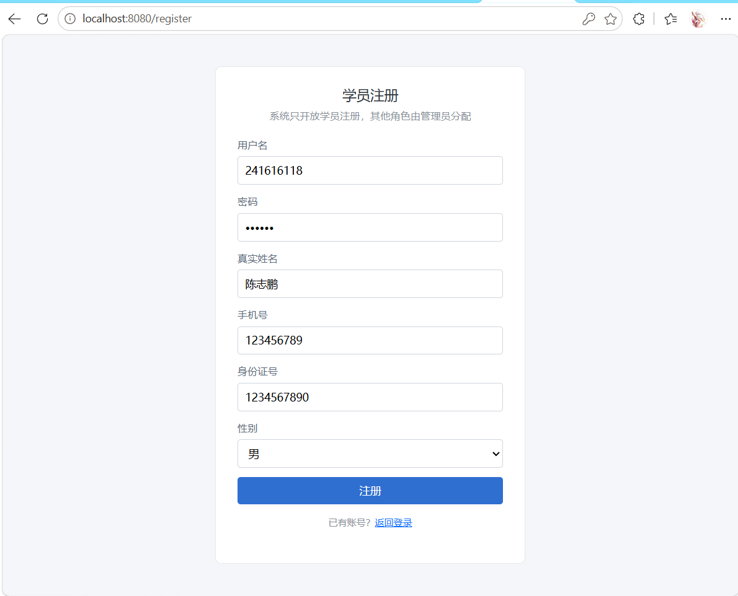
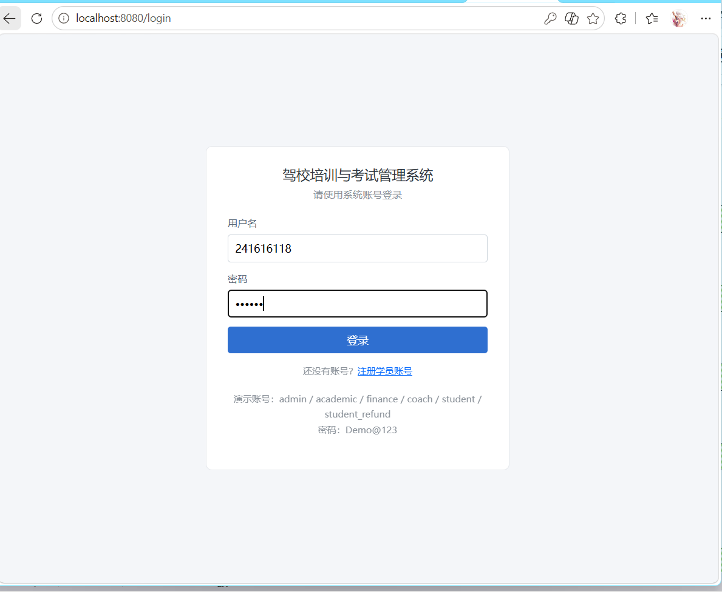

（2）学员报名界面截图(10分)
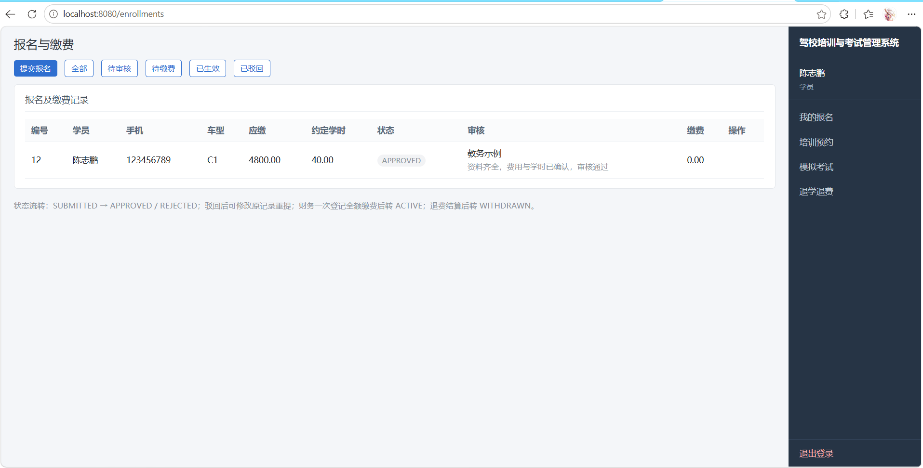

（3）培训预约界面截图(10分)
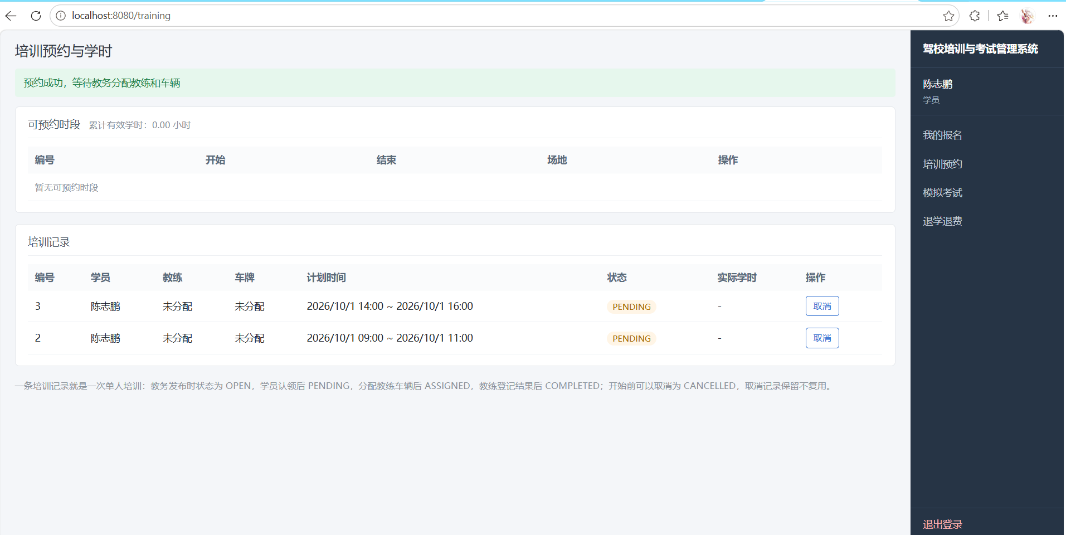

（4）题库与模拟考试界面截图(10分)
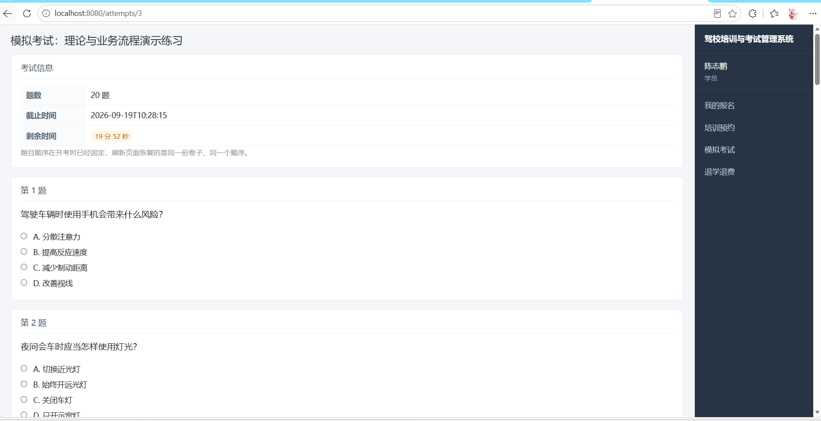

（5）退学与退费界面截图(10分)
